Internship within the Master program
at SRH Berlin University of Applied Sciences - Hamburg

Internship Report

Balyajith Babu
3119637

Submission date: 20:02:2026
Basic information on the internship
Name, first name (student) | Balyajith Babu
Study program | MSc Digital Transformation Management
Student number | 3119637
Internship type (e.g., practical phase I, II, III), if applicable | Practical Phase (Master Program)
Internship period | from: 28 April 2025 to: 01 October 2025
Weekly working time | 35 hours per week
Workload in hours | Total worked 770 Hrs
Company/Organization (incl. address) | DUO-Trade GmbH  Neumann-Reichardt-Straße 27-33  22041 Hamburg, Germany  www.konjak.de
Department | Warehouse Operations & Supply Chain Management
Internship supervisor on site | Bin Chen
Position of internship supervisor | Supply chain Manager
Telephone internship supervisor | +49 176 76792807
E-Mail internship supervisor | chen@duo-trade.de
Internship supervisor at SRH | Professor Dr. Christian Kapteyn

Table of Contents
1. General information and job description 1
1.1. 1.1 Expectations for the practical phase 1
1.2. Description of the internship employer 2
1.3. Description of tasks and results 3
1.4. Findings from the practical semester 4
1. Weekly report book 8
3. Confirmation of completion of the internship 14
4. Confirmation of accuracy 15

1. General information and job description

1.1 Expectations for the practical phase
Before starting my internship at DUO-Trade GmbH, I had several expectations both for the practical phase in general and for the specific experience I would gain in supply chain and logistics management.
From a general perspective, I expected the internship to bridge the gap between academic theory and real-world practice. My master's program in Digital Transformation Management has provided me with conceptual frameworks and theoretical knowledge, but I knew that actually working in a company would reveal the messy reality of how businesses operate day-to-day. I was curious to see how digital transformation concepts play out in a small company setting, particularly one that straddles traditional business methods like fax orders alongside modern e-commerce platforms.
Regarding the professional field, I had specific expectations about supply chain and logistics operations. I wanted to understand the operational complexity of managing both wholesale (B2B) and consumer (B2C) distribution channels simultaneously. From my studies, I knew these channels have different characteristics, but I wanted to see firsthand how a company manages the inventory allocation, documentation, and logistics requirements for both. I was also particularly interested in learning about traceability systems in food supply chains, as this combines regulatory compliance with operational efficiency, an area where digital systems can make significant impact.
I chose DUO-Trade specifically because of their hybrid business model and small team structure. Working in a company with around three to ten employees, where I would be part of a three-person warehouse team, meant that my contributions would be visible and meaningful rather than getting lost in a large organization. I expected this would give me broader exposure to different aspects of the operation and more responsibility than I might get in a larger company where interns often have narrowly defined roles. The fact that they operate both traditional order channels (fax, email) and modern digital platforms (Magento, eBay) aligned well with my interest in digital transformation.
In terms of competency development, I had several specific goals. For professional competence, I wanted to develop practical skills in warehouse management systems, logistics documentation, and multi-channel order management. I knew these would be valuable regardless of whether my future career focuses on operations or moves toward process improvement and digital transformation roles. For methodological competence, I hoped to improve my ability to design systematic workflows and solve operational problems under time pressure. The small team environment would likely present real problems that needed practical solutions. For social competence, I wanted to develop my ability to communicate effectively in an operational environment and learn when to solve problems independently versus when to escalate to management. Finally, for self-competence, I aimed to build stronger attention to detail, time management under varying workload conditions, and the initiative to identify and implement improvements without waiting to be told what to do.
I also had realistic expectations about challenges I might face. I expected there would be a learning curve in understanding the company's specific products, processes, and systems. I anticipated that working in a small team would mean less formal training and more learning-by-doing. I was prepared for the possibility that some processes might be less organized than in larger companies with dedicated process documentation. However, I saw these potential challenges as learning opportunities that would help me develop problem-solving skills and operational resilience.

Description of the internship employer
DUO-Trade GmbH is a small food import company based in Hamburg. They specialize in konjac pasta and organic diet products, basically low-calorie alternatives to regular pasta and rice for health-conscious customers. The company has about 11 employees total, with a three-person warehouse team where I did my internship.
What makes DUO-Trade interesting is that they run two different types of businesses at the same time. On one side, they do wholesale (B2B) selling to retailers and other businesses. On the other side, they sell directly to consumers (B2C) through their website www.konjak.de and on eBay. This means the warehouse has to handle both large pallet shipments and small individual orders every day.
The company's main products fall into a few categories. The Konjac Slim line includes different pasta shapes and rice alternatives made from konjac flour: spaghetti, fettuccine, penne, and rice-style products. There's also the Bio-Abnehm line, which is organic diet pasta in different forms. All of these are aimed at people who want to lose weight or eat healthier.
Everything happens at one location on Neumann-Reichardt-Straße in Hamburg, the office and warehouse are in the same building. This actually made things simpler because I could talk to people directly instead of dealing with separate facilities.
The B2B side of the business gets orders through fax, email, and customer portals. Some bigger customers like retailers have their own portals where they submit orders. The B2C side runs through Magento (e-commerce platform) for the website and eBay orders. In practice, this meant I had to check multiple places every morning to see what orders came in overnight. For shipping, B2B orders go out on pallets or in larger boxes through DACHSER (freight carrier), while B2C orders go out as small parcels through DHL. Pickup schedules are usually 2-3 times per week for each carrier, though this increases during busy periods.
One thing that became very important during my internship is traceability. Because these are food products, every item has a charge number (batch number) in addition to the product code. If there's ever a quality issue or recall, the company needs to know exactly which batch went to which customer. This meant I had to track not just what products I was packing, but also which specific batch they came from.
The products are imported from manufacturers in China. The supply chain manager handles the container ordering and supplier relationships, coordinating directly with Sichuan Sentaiyuan Biotechnology Co., Ltd. in Sichuan province. His ability to manage this international supply chain, including navigating time zones, cultural differences, and language, was essential for the business. The warehouse typically holds about 120 pallets of the main products. Each pallet has 240 boxes, and each box contains 10 packets, so we're talking about roughly around 288,000 packets in stock at any given time.
One challenge I noticed right away is that the company mixes old and new ways of working. Some customers still send orders by fax, while others use modern digital systems. This is pretty typical for small companies that can't just switch everything over to new technology overnight. They have to keep supporting whatever methods their customers prefer.
Regarding the application process, I became aware of this internship opportunity through a professional friend I met through Linkedin. The application process was straightforward, I submitted my CV and a cover letter explaining my interest in supply chain management and my relevant coursework in digital transformation. The supply chain manager, Mr. Bin Chen conducted the interview, focusing on my willingness to work in an operational environment and my interest in process improvement. He appreciated that I had realistic expectations about warehouse work and was genuinely interested in understanding how small companies manage logistics operations. The company was looking for someone who could both execute daily tasks reliably and potentially contribute ideas for improving processes, which aligned well with my background and interests.

Description of tasks and results
I worked as a Supply Chain Intern in the warehouse, reporting directly to Mr. Chen. My main job was to make sure orders got processed correctly and shipped on time, whether they came from wholesale customers or individual buyers online.
My day-to-day work covered five main areas:-
First, order intake and prioritization. Every morning, I had to check multiple places for new orders. B2B orders came in through fax, email, and customer portals. B2C orders came through Magento (from the website and eBay). The tricky part wasn't just collecting them, it was figuring out which ones to do first. I learned pretty quickly that you can't just process orders in the order they arrive. Some have earlier delivery deadlines, some need special labels, and some are scheduled for the next carrier pickup. Early in my first month, I noticed we sometimes scrambled on pickup days because urgent orders weren't identified early enough. I created a simple daily tracker in Excel that pulled together all orders from all channels and sorted them by actual delivery date, carrier requirements, label type needed, and current status. This gave the supply chain manager and the warehouse team better visibility into what needed to happen when, and it significantly reduced those last-minute rush situations before scheduled pickups.
Second, B2B shipping labels and documentation. For wholesale orders, I had to create packing lists and print the right shipping labels. This sounds simple, but there are different types. DACHSER orders need labels from the DACHSER eLogistics portal. Some customers require GS1 logistics labels (these are standardized labels with barcodes that include something called an SSCC, Serial Shipping Container Code). Getting the wrong label type or putting it in the wrong place on the pallet causes problems when the shipment arrives at the customer's warehouse. Large orders went out on Euro pallets, smaller ones in boxes.
Third, B2C order processing. Individual customer orders from the website and eBay were handled through Magento. I maintained the backend Excel file to batch these orders together, created DHL shipping labels, packed everything in boxes, and got them ready for DHL pickup days. On busy days, this could be 50-60 small orders.
Fourth, inventory tracking and traceability. This was probably the most important part of the job. We used an Excel sheet as a warehouse map showing where each pallet was located. But it wasn't enough to just track product codes, we also had to track charge numbers (batch numbers). This is crucial for food products. If there's ever a recall or quality issue, the company needs to know exactly which batch went where. I had to verify both the product code and charge number every time I picked items, and update the Excel map whenever pallets got moved.
Fifth, quality checks and staging. Before anything got shipped, I checked that the deliverable date matched the priority, the product code and charge number were correct, the packing list matched what was actually in the box or on the pallet, the labels were correct for the carrier, and everything was staged in the right zone for pickup. On pickup days, I helped make sure everything was ready when the DACHSER or DHL drivers arrived.The volume varied a lot. On quiet days, we might process 40 total orders (10 B2B and 30 B2C). Normal days were around 60 orders (15 B2B and 45 B2C). During peaks, usually when there was a promotion running, we could hit 80 orders (20 B2B and 60 B2C).
DACHSER and DHL pickups were normally scheduled 2-3 times per week, but during busy periods we'd arrange extra pickups to keep up with the volume.
The tools and systems I used daily were integrated to support the end-to-end order flow. Magento served as the e-commerce platform powering the customer-facing online store on www.konjak.de and managing eBay orders. Exact worked as the ERP system handling business management functions including order processing, inventory management, and fulfillment documentation. These two systems were integrated so that when orders came through Magento, they flowed into Exact for processing. I worked with Excel extensively as the practical interface layer, using it to maintain the warehouse location map, create the daily priority tracker, and batch B2C orders for efficient processing. For shipping, I used the DHL web portal for creating parcel labels and the DACHSER eLogistics portal for freight shipment documentation. When customers required standardized logistics labels, I used GS1 label printing software. Basic equipment included label printers and computers at the packing stations.
What I achieved during the internship: I got pretty good at making sure orders were ready on time for scheduled pickups. My documentation accuracy improved a lot, I rarely had to reprint labels or fix packing lists after the first few weeks. I reduced the number of times we couldn't find pallets by keeping the Excel map up to date. I also helped cut down on repacking situations where we caught errors before shipments went out. The priority tracker I developed became a standard tool that the team continued using, which felt like a meaningful contribution to improving the operation.

Findings from the practical semester
This internship taught me a lot about how supply chains actually work in practice, not just in theory. Before this, I understood the concepts from my studies, but seeing them play out in a real warehouse every day was completely different.
Running two businesses at once is complicated. The biggest thing that surprised me was how much harder it is to run both wholesale and consumer sales at the same time. Every day I handled both large pallet orders going to retailers and small parcels going to individual eBay customers. These need completely different processes, labels, and carriers. What works for one doesn't work for the other. In the first couple of weeks, I kept getting confused about which label format to use for which order type. Eventually I made myself a simple checklist to avoid mixing them up.
Batch tracking is crucial for food products. I learned very quickly why charge numbers matter in food logistics. It's not just a bureaucratic requirement, it's about being able to trace problems. One time in my third week, I almost picked from the wrong batch because two pallets of the same product looked identical. The only difference was the charge number on the label. After that close call, I started checking both the product code and the charge number every single time, even when I was in a hurry. This is what separates professional logistics from just moving boxes around.
Documentation accuracy isn't just paperwork, it affects real operations. Before this internship, I thought labels and packing lists were just admin tasks. But I learned that if you put a DACHSER label in the wrong spot on a pallet, it slows down the receiving process at the customer's warehouse. If your packing list doesn't match what's in the box, the customer has to spend time counting and checking. These "small" errors create real problems downstream. The supply chain manager told me about a time before I started when a wrong label caused a shipment to be delayed by two days. That taught me to treat documentation as seriously as the physical packing.
Simple systems need discipline to work. We used Excel for everything, the warehouse map, the priority tracker, order lists. These aren't fancy systems, but they worked really well when kept up to date. The problem is that updating an Excel sheet isn't urgent or exciting, so it's easy to skip it when you're busy. I learned this the hard way in Week 6 when I spent 20 minutes looking for a pallet that wasn't where the Excel sheet said it would be. Turned out someone had moved it to the overflow area and hadn't updated the map. After wasting that time, I became religious about updating locations immediately. The lesson: even basic tools only work if you actually maintain them.
Processing one order at a time is faster than it sounds. This was counterintuitive for me. At first, I thought it would be more efficient to print labels for 5-10 orders all at once, then pack them all. But we kept getting mix-ups, the wrong label on the wrong box, packing lists getting swapped. I started doing one complete order at a time: print the label, attach it to that specific order immediately, pack it, verify the packing list, seal it, then move to the next one. It felt slower, but we stopped having to reprint labels and repack boxes. Overall, it was actually faster because we eliminated the error correction time.
Working in a small team means your mistakes are visible. In a big warehouse with 50 people, one person's error might get absorbed by the system. In our three-person warehouse team, if I made a mistake, everyone knew about it immediately. This created healthy pressure to get things right the first time. It also meant I learned faster because I got direct feedback. If I messed up the priority sequence, I'd hear about it the same day, not weeks later.
Real challenges I faced include priority conflicts across multiple channels. In my first month, I was processing orders in the order they arrived, first come, first served. This seemed fair, but it was wrong. One day I was halfway through packing an eBay order when the supply chain manager asked if I'd processed the B2B order that needed to ship that afternoon. I hadn't even seen it because it had come in via fax while I was busy with the Magento orders. That's when I realized we needed better visibility across all our order sources. The daily priority tracker I developed solved this by consolidating everything into one view organized by actual delivery commitments rather than arrival sequence.
Maintained natural, human language label printing chaos was another learning experience. When I first started, I'd print multiple orders' worth of labels and packing lists at once to "save time." But then I'd have 10 labels and 10 packing lists sitting on the desk, and it was really easy to attach the wrong label to the wrong order. After one near-miss where I almost put a DHL label on a DACHSER pallet, I completely changed my approach. Now: print one order's documents, immediately clip them to that order, complete the packing, verify, seal, then start the next one. Zero mix-ups after I started doing this.
What this means for my career: This internship confirmed that I want to work in supply chain management, but specifically in roles that involve process improvement. I enjoyed the analytical side, figuring out why something wasn't working and designing a better process. The priority tracker and the one-order-at-a-time discipline were simple improvements, but they had real impact. I also learned that you can't improve processes without understanding the actual execution. If I'd just told the warehouse team to "be more organized" without working alongside them, it wouldn't have meant anything.
I'm now more interested in roles that bridge operations and technology, where you understand the warehouse floor but can also design better systems. I'd like to work on projects that take manual processes like our Excel warehouse map and turn them into proper systems, maybe with barcode scanning and real-time updates.
The internship also taught me that supply chain management isn't just about big strategic decisions. A lot of it is about getting hundreds of small details right, every single day. That requires discipline, attention to detail, and the ability to learn from mistakes quickly. These are skills I'll keep developing throughout my career.
Regarding practical job requirements, I learned that entering the supply chain field requires a combination of technical knowledge (understanding systems like ERP, WMS, e-commerce platforms), operational discipline (attention to detail, systematic checking procedures), and problem-solving ability under time pressure. The specific software varies by company, but the underlying principles of accuracy, traceability, and systematic workflows are universal. I also discovered that soft skills like communication, knowing when to escalate issues, and working reliably in small teams are just as important as technical competencies.
I believe I already possess several relevant competencies: analytical thinking that helps me identify process improvements, willingness to work hands-on in operational roles, and adaptability to learn new systems quickly. However, I need to continue developing my technical expertise in warehouse management systems and supply chain software, deepen my understanding of logistics regulations and compliance requirements, and build more experience with scaling processes from manual to automated systems. The Excel-based systems at DUO-Trade worked for their scale, but I need to learn how these processes would be implemented in larger operations with dedicated WMS and automated tracking.
In terms of teamwork versus independent work, I performed most daily operational tasks independently after the initial training period, checking orders, creating labels, packing shipments, updating the warehouse map. However, priority setting, exception handling, and process changes were always coordinated with the supply chain manager. This balance helped me develop both autonomous execution capabilities and collaborative decision-making skills.
I had meaningful intercultural experiences during the internship, particularly through exposure to the company's international supply chain operations. While the internship was based in Hamburg, I gained insight into how DUO-Trade manages its relationship with Sichuan Sentaiyuan Biotechnology Co., Ltd., their manufacturing partner in China. I had access to supplier information and manufacturing details, which gave me visibility into how the supply chain manager coordinated container orders, managed lead times, and handled quality communications across an 8-hour time zone difference. Observing how he navigated both the language barrier and cultural differences in business communication taught me that successful international supply chains require more than just logistics expertise, they require cultural awareness and relationship management skills. I saw how direct communication styles that work in German business contexts needed to be adapted when working with Chinese partners, where relationship-building and indirect communication are often valued. Working in a German business environment also exposed me to German workplace culture, including directness in feedback, emphasis on systematic processes and documentation, and strong separation between work and personal time. These cultural observations reinforced that global supply chain management involves understanding not just the technical and operational aspects, but also the human and cultural dimensions that influence how business gets done across borders.
After this internship, my career goals have become more focused. I want to pursue roles in supply chain operations or logistics consulting where I can combine hands-on operational understanding with process improvement and digital transformation initiatives. Specifically, I'm interested in positions that involve implementing or optimizing warehouse management systems, improving operational workflows in distribution environments, or helping small and medium enterprises modernize their logistics operations. The internship showed me that there's significant opportunity to add value by bringing together operational experience and digital solutions thinking, many smaller companies operate with manual processes that could be systematically improved without requiring massive technology investments. This intersection of practical operations knowledge and digital improvement capability is where I see my career developing.

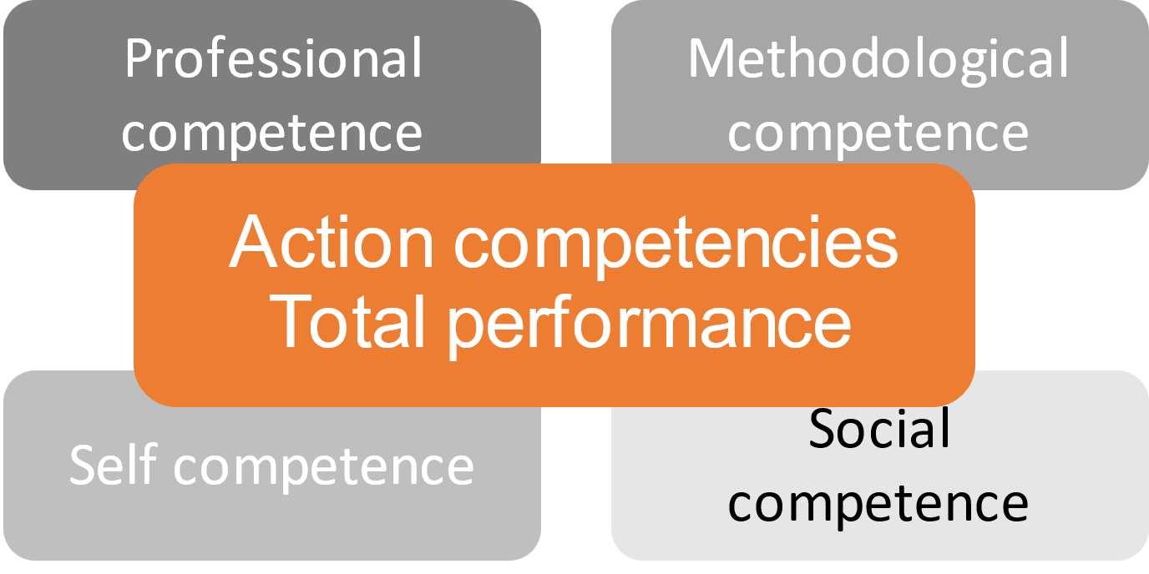
Weekly report book
Definition of CORE competency goals
Source: Rózsa, J., Edinger, S., Schöler, S., Kling, P., & Gusset-Bährer, S. (2017). CORE-gerechte Modulkonzeption: Ein Leitfaden (1st ed.). Good Practice in CORE-Teaching: Vol. 3. Heidelberg: Heidelberger Hochschulverlag, S. 25-29

Professional competence (Fachkompetenz)
Professional competence (cf. Pfäffli, 2005; Kopf, Leipold, & Seidl, 2010; Nerdinger, Blickle, & Schaper, 2011) refers to specialized knowledge and methods that are necessary for accomplishing specialized tasks and solving specialized problems.
Professional competence includes, for example:
- expert knowledge
- expert skills
- language skills

Methodological competence (Methodenkompetenz)
To achieve a goal, it is necessary to proceed methodically or systematically; in doing so, one acts according to a plan. Methodological competence is therefore understood as planned behavior. Methodological competence includes knowledge, skills and abilities that enable tasks and problems to be mastered by selecting, planning and implementing sensible solution strategies.
This requires, among other things:
- ability to gather information
- planning ability
- ability to analyze
- decision-making ability
- transferability

Social competence (Sozialkompetenz)
Social competence encompasses all knowledge, skills and abilities that enable one to act appropriately in relationships with people. To relate to others successfully and work constructively with them, it is necessary to be responsive to their needs.
Social competence includes, for example:
- ability to work in a team and willingness to help others
- social responsibility
- communication skills
- ability to delegate
- tolerance
- ability to accept criticism

Self-competence (Selbstkompetenz)
A self-competent person can behave appropriately in the environment and adapt to it and its values out of insight. He/she is able to handle tasks by her/himself and on his/her own responsibility out of his/her own insight.
This includes:
- willingness to take responsibility
- motivation
- initiative and commitment
- ability to organize oneself
- willingness to learn and perform
- ability to accept criticism

Week 1  period: 28.04-04.05.2025 | Professional (P), methodological (M), social (So) and self-competence (Se) objectives | Activities in detail
 | Order intake via fax/email (P)  Deliverable date verification (M)  Packing list preparation (P)  Excel tracking setup (M) | First week: learned order intake from fax/email, checked delivery dates, started creating packing lists, set up basic Excel tracking. Overwhelming at first, so many order sources. Learned why delivery dates matter more than arrival order.
Signature internship supervisor | 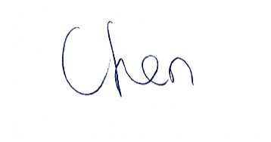
Week 2  period: 05.05-11.05.2025 | Professional (P), methodological (M), social (So) and self-competence (Se) objectives | Activities in detail
 | DHL label printing (P)  Carton packing (P)  Magento order processing (P)  Carrier staging organization (M) | Started handling DHL labels, packed B2C orders in boxes, processed Magento orders, organized staging by carrier. B2C volume jumped to 50+ orders one day. Learned to batch Magento exports to avoid last-minute printing chaos.
Signature internship supervisor | 
Week 3  period: 12.05-18.05.2025 | Professional (P), methodological (M), social (So) and self-competence (Se) objectives | Activities in detail
 | B2B priority coordination (M)  Excel tracker development (M)  Multi-channel order consolidation (M)  Team communication (So) | Built priority tracker to organize B2B orders across channels, updated tracker throughout day, coordinated sequence with manager. Tracker immediately helped, no more 'hidden urgent' orders discovered too late.
Signature internship supervisor | 
Week 4  period: 19.05-25.05.2025 | Professional (P), methodological (M), social (So) and self-competence (Se) objectives | Activities in detail
 | DACHSER label creation (P)  GS1 label printing (P)  Pallet assembly support (P)  Label placement verification (M) | First time creating DACHSER labels through eLogistics, printed GS1 labels, helped build pallets, checked label placement. Customer complained about hard-to-scan label. Learned placement matters for downstream efficiency.
Signature internship supervisor | 
Week 5  period: 26.05-01.06.2025 | Professional (P), methodological (M), social (So) and self-competence (Se) objectives | Activities in detail
 | Charge number verification (P)  Batch traceability documentation (M)  Quality check protocols (M)  Attention to detail (Se) | Focused on charge number verification, documented batch info, established check procedures. Nearly picked wrong batch under time pressure. Started double-checking charge numbers every time.
Signature internship supervisor | 
Week 6  period: 02.06-08.06.2025 | Professional (P), methodological (M), social (So) and self-competence (Se) objectives | Activities in detail
 | Excel warehouse map updates (M)  Pallet location tracking (P)  Discrepancy resolution (M)  Problem-solving (Se) | Updated warehouse map in Excel, tracked pallet moves, fixed location discrepancies, checked overflow zones. Spent 20 minutes searching for pallet not in mapped location. Made immediate updates non-negotiable after this.
Signature internship supervisor | 
Week 7  period: 09.06-15.06.2025 | Professional (P), methodological (M), social (So) and self-competence (Se) objectives | Activities in detail
 | Multi-box order packing (P)  Carton labeling (P)  Packing list reconciliation (M)  Exception communication (So) | Packed multi-box orders, labeled cartons, reconciled packing lists, communicated exceptions to manager. Similar product packaging caused near-miss. Added product code verification before sealing anything.
Signature internship supervisor | 
Week 9  period: 23.06-29.06.2025 | Customer portal order processing (P)  Deliverable date analysis (M)  Carrier requirement matching (M)  Multi-channel coordination (M) | Processed customer portal orders, analyzed delivery date patterns, matched carrier requirements. Portal orders sometimes got missed because separate from fax/email. Added them to main tracker.
Signature internship supervisor |  | 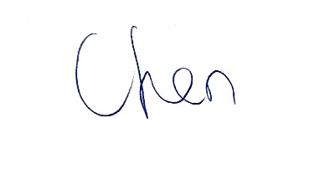
Week 11  period: 07.07-13.07.2025 | Inventory reconciliation (P)  Location map validation (M)  Discrepancy documentation (M)  Data accuracy maintenance (Se) | Reconciled inventory counts, validated Excel map accuracy, documented discrepancies for manager. Found three pallets in wrong locations. Systemic cleanup of map improved pick speed noticeably.
Signature internship supervisor |  | 
Week 13  period: 21.07-27.07.2025 | Peak volume management (P)  Batch processing optimization (M)  Material pre-staging (M)  Adaptability (Se) | Peak week: 75+ orders. Batch processed efficiently, pre-staged materials, reduced bottlenecks. Learned that pre-staging packaging materials earlier reduces crunch time before pickup.
Signature internship supervisor |  | 
Week 15  period: 04.08-10.08.2025 | Workflow sequence refinement (M)  One-at-a-time discipline (M)  Reprint reduction tracking (M)  Process improvement (Se) | Focused on workflow sequence, enforced one-at-a-time discipline, tracked reprint reduction. Reprint rate dropped significantly. Sequential processing slower per order but faster overall.
Signature internship supervisor |  | 
Week 17  period: 18.08-24.08.2025 | Priority conflict handling (M)  Delivery date rule enforcement (M)  Processing sequence optimization (M)  Decision-making (Se) | Handled priority conflicts, enforced delivery date rules, optimized processing sequence. Established clear rule: process by delivery date, not arrival time or channel source.
Signature internship supervisor |  | 
Week 19  period: 01.09-07.09.2025 | Quality check procedures (M)  Pre-sealing verification (M)  Staging zone confirmation (M)  Quality focus (Se) | Established quality check procedures, verified everything before sealing, confirmed staging zones. Realized final inspection isn't enough, need checks throughout process, not just at end.
Signature internship supervisor |  | 
Week 21  period: 15.09-21.09.2025 | Process documentation (M)  Workflow standardization (M)  Improvement opportunity identification (M)  Knowledge transfer (So) | Documented processes for handover, standardized workflows, identified improvement opportunities. Created simple process notes so next person doesn't have to figure everything out from scratch.
Signature internship supervisor |  | 
Week 23  period: 29.09-01.10.2025 | Final dispatch support (P)  Documentation verification (M)  Excel file handover (M)  Handover preparation (So) | Final week: wrapped up dispatch support, verified all docs, handed over Excel files and trackers to manager. Prepared handover summary of trackers/maps used and recurring issues observed for continuity.
Signature internship supervisor |  | 

3. Confirmation of completion of the internship

We hereby confirm that Mr. Balyajith Babu

Name of the student | Balyajith Babu

completed a mandatory internship

from 28 April 2025 to 01 October 2025

with 35 hours a week

total _______________770_____________ hours

in our company / organization:

Company / Organization  (incl. address) | DUO-Trade GmbH  Neumann-Reichardt-Straße 27-33  22041 Hamburg, Germany
Department | Warehouse Operations & Supply Chain Management
Internship supervisor on site | Bin Chen
Function | Supply chain Manager / Supply Chain Responsible also warehouse manager
Telephone | +49 176 76792807
E-Mail address | chen@duo-trade.de



Hamburg ,19/02/2026 __________________________________________
(Location, date) (Internship supervisor on site, stamp)

4. Confirmation of accuracy

I hereby confirm the accuracy of the information I have provided regarding the internship phase I have completed. I have written the report by myself and have marked other sources as such. I have used AI assistance to help reformulate sentences and improve the language.
Hamburg, 20/02/2026 | 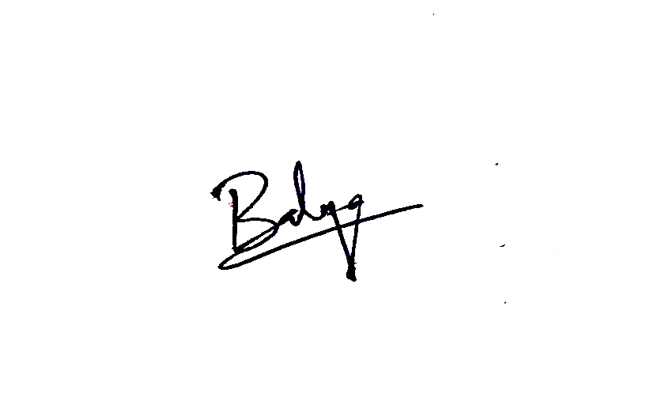
Location, date | Signature (student)

